Dual-Shaft Horizontal Cutting Machine ZRS-D1300
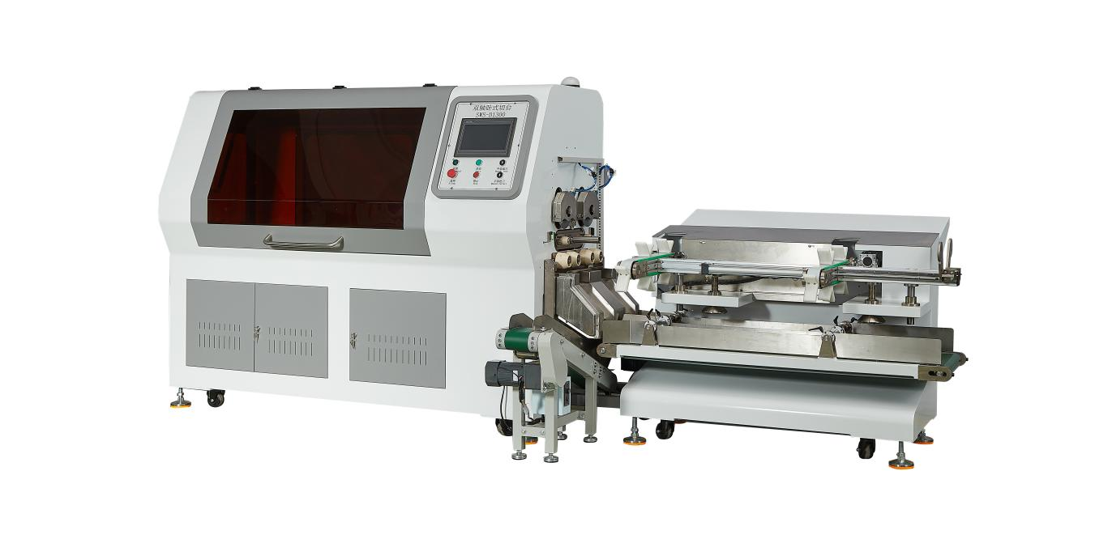

Equipment Layout：
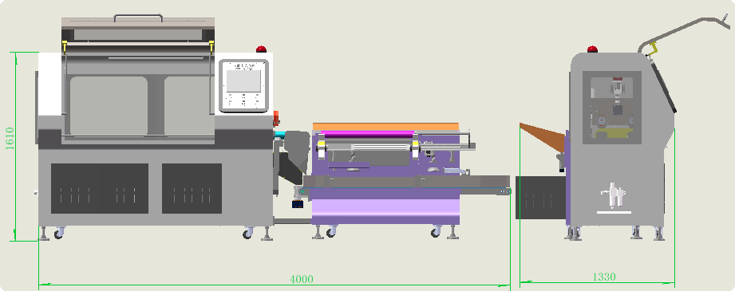
Basic Use：
Mainly used for slitting materials such as dust-proof adhesive rolls, dust-removal films, tear-free dust removal paper rolls, PCB dust removal paper, lint removal paper rolls, PP dust removal rolls and PE dust removal rolls.
Product Characteristics:
- Equipped with HCFA motion control system, featuring accurate parameters and high speed.
- Main spindle driven by 1500W three-phase asynchronous motor; circular blade driven by 750W servo motor with planetary reducer.
- Cross travel adopts HIWIN 2020 ball screw + 25 linear guide, driven by 750W servo motor; positioning tolerance within 1000mm: ±0.02mm.
- Blade feed adopts HIWIN 2005 ball screw + 25 linear guide, driven by 750W servo motor, ensuring feeding strength and accuracy.
- Waste pusher adopts HIWIN 1610 ball screw, driven by 400W servo motor, ensuring accurate feeding position.
- Material ejector adopts HIWIN 2005 ball screw + 25 linear guide, driven by 750W servo motor, preventing material damage.
- Blade holder and cross travel components undergo QBQ surface treatment, enhancing hardness, wear resistance, corrosion resistance and reducing deformation.
- 10-inch main touch screen for simple and intuitive operation.
- Integrated lighting: light for electrical cabinet door open, light for machine cabinet door open, operation lighting.
- Max. diameter of circular blade: 160mm, with stainless steel protective blade housing.
- Manual height adjustment at feeding end to adapt to different finished product diameters; cylinder-driven feeding.
- Automatic front/rear waste discharge; waste conveyed via inclined line for packaging.
- Finished products discharged automatically and orderly, directly connectable to packaging equipment.
- High-speed rotating expanding chuck with stable clamping, no damage to paper core; no slipping during slitting to prevent blade chipping.
- Designed for inline connection behind automatic rewinding machines, enabling automatic loading, slitting, waste discharge and orderly finished product discharge, reducing labor costs and adapting to automated production lines.

Main Technical Parameters：
Model | ZRS-D1300
paper core | Customizable (interchangeable)  38/50/76 mm
Min. Slitting Width | 0.5-1300mm
Max. Slitting Diameter | 80MM
Max. Diameter of Slitting Blade | 160mm
HMI Operation | 10寸/inch
power supply | 380V(220V customizable), 50/60HZ/5KW
air pressure | 5KG
Machine size | 4000*1550*1600
Net Weight | 1.2T

Configuration Parameters:
Model | SWS-D1300
Main Touch Screen | 10寸/inch HCFA
Discharge Conveyo | 200w
Rack Wall Plate | 80×80 square tube + 20mm steel plate
Motion Controller | HCFA
Main Spindle Three-Phase Asynchronous Motor | 1500W HCFA
Main Spindle Inverter | 5000W HCFA
Circular Blade Servo Motor | 750W HCFA
Circular Blade Driver | 750W HCFA
Cross Travel Servo Motor | 750W HCFA
Cross Travel Driver | 750W HCFA
Blade Feed Servo Motor | 750W HCFA
Blade Feed Driver | 750W HCFA
Pusher Servo Motor | 400W HCFA
Pusher Driver | 400W HCFA
Ejector Servo Motor | 750W HCFA
Ejector Driver | 750W HCFA
Waste Inclined Conveyor | 120W
Planetary Reducer | Smetre
Air Switch | chint
Switching Power Supply | Mingwei
Photoelectric Sensor | BOJKE
Proximity Switch | Yangming
AC Contactor | Schneider
Relay | IDEA
Push Button Switch | Schneider
三色报警灯  Three-Color Alarm Lamp | 台邦TʌYB
Lighting | Waterproof LED
Blade Feed Linear Guide | HIWIN 25
Blade Feed Ball Screw | HIWIN 2005
Cross Travel Linear Guide | HIWIN 25
Cross Travel Ball Screw | HIWIN 2020
Pusher Ball Screw | HIWIN 1610
Ejector Linear Guide | HIWIN 25
Ejector Ball Screw | HIWIN 2010
Solenoid Valve | asicko
Cylinder | AIRTAC
Linear Guide Rail | HIWIN
Magnetic Switch | AIRTAC
Main Spindle Chuck3-inch | DC53
Bearing | NSK
Machine Body | Imported baking paint
Circular Blade | Customizable per material, max. 160mm
Toolbox | 1set

